Dave Sulzer

Music Math and Mind
the physics and neuroscience of music

working version
September 1, 2019

Nota bene

This book can be understood with no knowledge of math beyond grade school level multiplication and division. When the mathematics could be more advanced, we still explain it using only these functions.

This isn’t intended to be a typical “pop science” book read in a single reading: instead, read a chapter you are interested in, absorb what you can, and when you re-read it down the road you will understand more. Genuinely, I have been a professional scientist for three decades, and still need to learn and re-learn these basic concepts. To some extent, math and science are foreign languages, and it’s fine and perhaps best to absorb these insights little by little: some required humanity centuries to comprehend, and particularly towards the end of the book, there is far more to be discovered.

For ambitious readers, the blue boxes use simple math to go a bit further, and can be safely ignored by readers without losing the flow. Even these only require multiplication and division.

Yellow boxes are tangential remarks.

Table of Contents
Nota bene 2
Introduction 7
Listening 10
1. Parameters of Sound 12
Figure 1.1 Waves at the beach. 13
Differences between beach waves and sound waves 14
Figure 1.2 Sirens. 15
What ranges of frequencies are used in music? 15
Figure 1.3 A440 and its octaves represented by notation and waves. 22
Figure 1.4 The Most and Least Wanted Paintings 25
Figure 1.5 The Doppler effect. 28
Listening 29
2. Math of pitch, scales, and harmony 31
Figure 2.1 Replica of one of the the oldest flutes discovered, 32
Figure 2.2. a monochord 33
Octaves and tetrachords 35
Figure 2.3 UT a deer. 36
Just intonation 37
Figure 2.4 Images of a begena and lyre 37
Figure 2.5 Kepler’s music of the planets. 40
The “circle of fifths” and the 12 note scales 40
The “Pythagorean comma”, irrational numbers, and cosmological crises where the natural order breaks down 42
What to do? 43
The irrational calculations of equal temperament. 44
Choices 45
Figure 2.7 Harry Partch and his microtonal instrument ensemble. 47
Listening 48
3. Waves and harmonics 51
Circles, strings and clocks 51
Figure 3.1 The rotations of a clock hand 52
Waves in the real world have harmonics 54
Figure 3.2 The overtone series. 55
Making harmonics visible 56
figure 3.3. of two people waving a slinky 56
Figure 3.4 Hallway speaker set up: 57
Figure 3.5 Chaldni figures 58
From 58
plateshttps 58
Wind instruments with open and closed ends 58
Figure 3.6 Sound waves formed in tubes 59
Seashells, horns, trumpets and stationary waves 61
Ocarinas and resonance chambers 63
Figure 3.8 cello resonance 64
Listening 65
4. Math of sound and resonance 67
The “spectra” of harmonics make the differences between sounds 68
Figure 4.1 of a flute sine wave and clarinet square wave. 70
AND add the Fourier spectrum 70
Beating, consonance, and noise 71
Figure 4.2 A fundamental 100 Hz wave 72
Figure 4.3 of waves 72
Figure 4.4 a 440 Hz sine wave 72
Figure 4.5 The same fundamental with the same four harmonics each detuned by 5 Hz. 73
The colors of noise 73
Figure 4.6 Colors of Noise 75
Consonance and dissonance in the worlds of music 75
The voice as an instrument 75
Listening 78
5. Math in some musical structures 80
For Greek and middle eastern lyric rhythms, use the feet 80
Figure 5.1 Sappho 82
The math of composite rhythms 82
Medieval talea 85
Figure 5.2 Derivation of a tenor line in a motet. 86
Syncopation 86
Canons and Riddle Canons 88
Figure 5.3 The first riddle canon 90
Figure 5.4 a Koch Snowflake 91
Listening 92
The Sense of Hearing 95
Figure X The Sense of Hearing by Jan Breughel 95
6. Brain mechanisms of rhythm and the private synapse 96
Thinking about current 96
The nervous system produces electricity 99
Figure 6.1 Cavendish’s artificial torpedo. 100
Figure 6.2 Galvani’s drawing of a lightning rod 101
The brain produces electricity 102
Producing a heartbeat with batteries 103
Figure 6.4 cycle of sinoatrial action potential, 105
Neurons are batteries 105
Figure 6.5 of neuronal action potential. 107
Neuronal firing and private synapses 108
Producing neuronal clocks in rhythm 108
Figure 6.6 of an event related potential. 110
Listening 110
7. Neural mechanisms of emotion and the social synapse 112
Adrenaline, the classic hormone 112
Goosebumps 114
Private and social synapses 114
Figure 7.1 Olds’ reward pathway. 116
Dopamine transmission is implicated in the effects of listening to music 116
Social and private synapses meet, win friends, and influence people 117
Figure 7.2 A striatal microcircuit. 119
Listening 120
8. Ear physiology: how air waves become sound 121
Step 1: Why big ears? 121
Figure 8.1 The ear. 122
The ear drum, where air waves become mechanical waves 122
Figure 8.2 Vibration of the eardrum. 122
Bones of the middle ear and how air waves are transformed to fluid waves 123
The cochlea, a snail with seawater 123
Hair cells transform mechanical sound waves to electrical sound waves 126
Cochlear otoacoustic emissions 129
Listening 130
9. Deep brain physiology of sound 131
The auditory nerve broadcasts on 30,000 channels 131
Figure 9.1 of auditory nerve response to musical intervals. 133
Sound reaches its first synapse within the brain 133
Marching to the midbrain 133
Onward to the thalamus 134
The auditory thalamus projects into the striatum 135
The auditory thalamus projects to the cortex 135
Figure 9.2 Penfield’s cortical homunculus. 137
Figure 9.3 the regions of the temporal cortex 138
Maps of the aspects of sound in the auditory cortex 138
Sounds can be reconstructed from the activity of the auditory cortex 139
Figure 9.4 Neuronal response to human spoken phonemes 139
Figure 9.5 cortical response to human speech in the temporal cortex 140
The interpretive cortex, the stuff that dreams are made of 141
Figure 9.6 An operation in the experiential cortex. 142
Listening 144
10. Sound disorders, illusions and hallucinations 145
Common and benign illusions 145
Hearing voices 147
Seizures driven by music 147
Tone deafness and amusia 148
Tinnitus and ringing in the ears 149
Mechanisms that produce deafness and the effects of loud sound 150
Listening 153
11. Animal sound, song and music 154
How birds sing 155
Figure 11.1 American bird sonograms. 155
Why birds sing 156
Birds who imitate other species 157
Night flight calls 158
Insect music 159
How insects hear 159
Figure 11.2 A katydid ear 161
How insects sing 162
Singing by other primates 163
Sound under water 164
Singing amphibians and reptiles 166
Whale song and hearing 167
Songs of the baleen whales 168
Humpback whale musical conservatories 169
Long distance calls of the fin whale and of elephants 170
Echolocation by bats and toothed whales 171
Animals improvising on musical instruments 173
Chimpanzees and bonobos 173
Songbird instrumentalists 174
The Thai Elephant Orchestra 175
Designing elephant xylophones. 177
Figure 11.4 The Thai Elephant Orchestra 180
Other musical species and us 183
Listening 184
Acknowledgements 186
Appendix 1 187
Musical pitch to frequency table 187
Appendix 2: Further reading 188
The author 189
Selected compositions with classical notation 190
Selected Discography 191
Back Cover 194

Introduction

- who needs a book on math and the nervous system’s roles in music?

Some questions that introduce these chapters evade clear answers, but this has one: no one needs this book.

The creation and appreciation of music do not require knowledge of the math or biology that allow it to exist. These topics are not taught to music students.

Music education is rooted in a system developed to train orphans and abandoned children in renaissance Naples. The conservatori meant “places to save children” and music provided a way for those without a family trade to make a living. The first conservatory, Santa Maria de Loreto, founded in Naples in 1537, was immensely successful, training composers Alessandro Scarlatti and Domenico Cimarosa. The movement spread, with Antonio Vivaldi teaching at the Ospedale della Pieta for abandoned girls in Venice, and composing the Four Seasons for the school orchestra. The system migrated to the Paris Conservatory in 1784, and from there throughout the world, as conservatories broadend to accept students from any family background.

Over these five hundred years, the purpose of musical training has always been to impart tools to make a living. For example, Johann Sebastian Bach, a god for composers, taught music theory classes at the Leipzig Thomas School so that students could perform on the organ in church services. Bach’s lessons were bound in a book, Precepts and Principles for Playing the Through Bass of Accompanying in Four Parts (1738), modeled on the Musical Guide (1710) by Friedrich Erhard Niedt, a pupil of J.S. Bach’s cousin Johann Nicolaus Bach. These books clearly delineate the techniques used by the Bach family, with rules for composing fugues and the popular dances like sarabandes and jigs: with effort, they will help you create a piece in the tradition.

In contrast, the creation of music in some other styles requires no “theory”, or even instrumental or singing lessons, but simply talent, opportunity and work. A pioneer of this approach was the French radio engineer Pierre Schaefer, who in the 1940s composed by splicing recording tape. Fifty years later, this was extended by the hiphop group Public Enemy, who created instrumental tracks completely from juxtaposing recorded sounds. Schaefer and Public Enemy prove that with perseverance and tools, one can create brilliant music immediately without requiring years of training.

A thoughtful perspective on the issue of training vs. instinct in creating music is from the American composer and violinist Leroy Jenkins. Leroy grew up in the 1940s performing classical violin duos on the Chicago streets with his classmate, future rock n’ roll pioneer Bo Diddley, when public schools provided lessons on instruments. Indeed, many of Leroy and Bo’s cohort at Chicago’s DuSable High School trained under the violinist/teacher Walter Dyett, whose students included a high percentage of the top figures in jazz and pop, including Eddie Harris, Dinah Washington, Johnny Hartman, Nat King Cole, Gene Ammons and Clifford Jordan.

Despite the success of Walter Dyett and others, starting in the 1970’s, support for music lessons in many American public schools evaporated. Young people, like the Bronx’s DJ Kool Herc and Afrika Bambaataa, adapted the sparse instrumental resources around them, drum machines and turntables from stereo supply stores, and used them to create a style Bambaataa named hiphop, presently the most popular style in the world.

Leroy’s comment was they, like his generation, developed a style from what was available, because even in a desert of resources, “you can’t kill human creativity”.

An extreme example of creating music without training or theory would be from children the first time they were given musical instruments. In the 1960s, the electronic music pioneer Daphne Oram did just this by coaching British high school students to compose with kitchen and household machines like vacuum cleaners, and they made a wonderful record.

Another approach is to ask children what music they like to listen to and then coach them on how to do something like it. We have tried this in projects to do just that with groups of children as young as 3 years old in Brooklyn, East Harlem, and the Mayan highlands of Guatemala. Each group made their own record in styles they were familiar with on instruments they encountered for the first time. As a rule their music is quite unconcerned with virtuosity on instruments but very aware of conveying feelings and stories, and some of their pieces seem fresher and more direct than work by professionals.

Whether music is made after years of training and knowledge, or by children playing instruments the first time, underlying all of this artistic activity is an ancient and direct line of study initiated by natural philosophers in China, India, Egypt and Greece. These discoveries underpin the creation and comprehension of music but are unknown to almost all musicians.

Here are some basic questions on math, physics, and the nervous system that musicians care about but are not discussed in music theory classes:

- Which sounds are in and out of tune, and how are musical scales derived? Is it true that scales are really never in tune?
- What are overtones and harmonic sounds, and are they different?
- Sound is formed from air waves that move in space and time. What physical shape are these sounds, how big, fast, and heavy? How are sound waves in air different under water or through the earth?
- Why do instruments sound different from each other? Why do larger instruments play lower pitches?
- We have only two eardrums and two ears, so how can we distinguish many simultaneous sounds?
- Is there a mathematical definition of noise and consonance?
- How does the brain understand what it is listening to? Warning; this does not yet have a satisfying answer.
- How are emotions carried by music? Ditto.
- How do other animals hear and make sound differently than us?

If these issues not taught to musicians and music lovers, it is not from lack of curiosity. Artists have of plenty of that, and this book is for them. You can’t kill human creativity, and you may possibly use this knowledge to create new explorations.

Listening

Pierre Schaeffer’s Etude aux casseroles, dite “pathetique” was composed on recording tape in 1948. In this piece, Schaeffer created new music by assembling prerecorded sounds including bits of harmonica playing by the blues musician Sonny Terry. It still sounds like music from the future.

Daphne Oram was another pioneer of electronic music. For a project in 1968, likely inspired by John Cage who used transistor radios for compositions, she coached English schoolchildren to create music using household appliances. Listen to Adwick High School Number 3 by Linda Parker, a piece for metal sheet, tin lips, chimes, wire, frame, keyboards, wood block, echo sander, scraper and whistle.

It’s not hard to find “instrumentals” of classic hip hop tracks, that is, the musical portions without the vocals. The first hip hop hit, 1979’s Rapper’s Delight by the Sugar Hill Gang, was produced by the rock n’ roll and disco singer Sylvia Robinson (her group Micky and Sylvia had a major hit in the 1950s, Bo Diddley’s song Love is Strange), and used a live band playing a theme from the disco group Chic, augmented by a dj playing short phrases on a turntable.

Only three years later, Planet Rock by Afrika Bambaataa in 1992, rather than being performed by professional rock / R&B players and live drummer, used only a drum computer (known as a drum machine, here the classic TR808), with a vocorder, a turntable, and keyboard player John Robie playing a theme from the German electronic rock group Kraftwerk on synthesizer. The style, which they called electronica, sounded more rigid than the Sugar Hill style on purpose, suggesting a robotic future.

About five years later, Public Enemy further welded Schaeffer’s approach to hip hop by assembling music from only large numbers of looped samples. They could do this without recording tape due to the advent of faster computers that recently become available in studios. With producers Hank Shocklee and Eric Sadler, their looped samples produced the ominous feel of their style: 1988’s Night of the Living Baseheads uses tiny bits from at least 20 different songs in its 3 minutes, including bits of Aretha Franklin and David Bowie and a lot from James Brown’s band.

The use of stripped down affordable instruments led to very different styles in the Bronx, Chicago and Detroit. The styles of Chicago house and Detroit techno were mostly established by musicians who had little training, although some including Larry Heard, the inventor of “deep house”, were virtuosos of jazz and pop. The instruments central to these styles were - and continue to be - turntables, samplers, synthesizers and drum machines.

Leroy Jenkins, as you might imagine, created an extraordinary range of compositions. One approach he used was to write very simple but unusual phrases as a basis for improvised longer compositions. A good start is the album Space Minds, New Worlds, Survival of America.

Bo Diddley stopped playing the classical violin after he heard the blues singer and guitarist John Lee Hooker: he went on to build his own classic and distinctive electric guitars and his own style to become one of the pillars of rock n’ roll. I played second guitar with him and he told me that although his daughter wanted to play the violin, he discouraged it because “there’s no money in it”. He nevertheless had a hit in 1959 playing a violin blues, The Clock Strikes Twelve.

Da Hiphop Raskalz were 4 to 10 year-old students I coached at the Amber Charter School in East Harlem, New York City. None played an instrument, but they immediately learned to operate synthesizers and drum machines, and wrote their own lyrics and compositions, I only coached and mixed. Listen to I Want Candy by the Muffletoes and Do the Lollipop by Sweetness.

Yol K’u: Inside the Sun were Mayan speaking students from the Seeds of Knowledge school in San Mateo, Ixtatan high in the mountains, the first high school in that part of Guatemala. A few knew traditional pieces on the giant marimbas of the region, which had originally arrived from Africa, and we coached the kids to compose their own pieces using colored tapes on different pitches. Listen to Oracion de la Cruz.

The Tangerine Awkestra were 3 to 7 year-olds from Brooklyn who created original pieces on instruments they formerly didn’t know how to play, during a single rehearsal and recording session for a full CD in a single afternoon. The flutist and composer Katie Down and I coached them to first write a story, for which they chose a space alien invasion, and then compose music for it. They came up with brilliant avant garde “free improvisation” compositions. Try Aliens Took My Mom.

1. Parameters of Sound

- How can we measure music? How fast, long and tall is it?

When we hear a sound, something must move in the air for it to enter our ears. These are waves of air, which are challenging to imagine. Fortunately, ocean waves provide help.

On the beach, we see waves where the air meets the water. When you wade in the ocean, you feel the power of the wave at its highest pressure -- the peak or crest that pushes you toward the shore –- and feel an undertow at its lowest point, known as the trough. The ocean waves push and pull the air around them, creating air waves that we perceive as the sound of the ocean.

If ocean waves repeated regularly (periodically) at a speed of at least 20 waves a second, the air waves would be a musical tone. If you were underwater, you would hear the same musical note as in air, as the periodic water waves enter your ear.

Figure 1.1 Waves at the beach.

At the beach, you see waves where the air meets the water, caused by wind and weather conditions and ocean currents. You also hear the air waves driven by the push and pull of the water waves.

For a repeating or periodic wave, the wavelength, abbreviated as lambda (λ), is the distance between the waves, which can be measured between successive midlines or peaks or troughs. The amplitude of the waves is the height measured from the midpoint of a wave to its peaks or troughs measured in meters (m). The number of waves that occur during a period of time is the frequency, calculated as waves per second in units of hertz (Hz).

There is a wide range of water waves. Ripple waves, seen when the wind blows over a puddle, are short wavelength (a few centimeters), short amplitude and pretty rapid, usually several Hz. On California surfing beaches, the waves in a swell have wavelengths of about 150 meters, are in the range of a meter in height, and a much lower frequency, about 1 wave every ten seconds (0.1 Hz). A giant tsunami wave caused by an underwater earthquake can have a wavelength of over 100,000 m, be tens of meters in amplitude with a frequency of one wave per hour (1/ 3600 seconds = 0.0003 Hz or 0.3 thousandths of a Hz). The tides are also waves and at once per day its frequency is 1/86400 seconds = 12 millionths of a Hz.

At the beach, we mostly notice stationary waves, a.k.a. standing waves, where individual water or air molecules stay relatively local, moving in circles or up and down or back and forth as the water or air particles alternate between a cycle of high and low pressure. This can be pictured from a toy boat next to our figure in the ocean that bobs up and down or back and forth with the waves but isn’t swept to the shore or washed out to sea. This is similar to sound waves, as air or water particles in sound oscillate back and forth locally into local peaks and way from the troughs.

Beach waves also differ in some ways from sound waves. When sound is emitted from a singer or instrument, as we will see with a siren, the air particles don’t move and up and down but instead are alternatively compressed and relaxed (called rarefication): this is called a longitudinal wave. (The up and down peaks in an oscilloscope or digital file show the density of air particles, not actual up and down waves.)

The unit of numbers of waves per second is also known as cycles per second, which is equivalent to Hz, and named after the physicist, Heinrich Hertz (1857-1894). One wave per second is a frequency of 1 Hz.

Air waves at 1 Hz are too slow to hear, but elephants begin to hear frequencies above 15 Hz. We begin to hear low vibrations at around 20 Hz. These very low frequencies are sometimes used in music: the low notes of a bass with a low B string “extension” is 30 Hz, and occasionally a church organ will use a very low C at 16 Hz that is genuinely below our ability to hear a note.

Musicians use these letter names, but for non-musicians: the convention in English speaking countries is to name the notes of the scale from lower to higher pitches as A B C D E F G, and then start all over again at the next higher A. The distance between the names of any of these notes and its next repeat is known as an octave. If this doesn’t yet make sense, stick with us, it will soon.

At the high end of our hearing, teenagers extend up to about 20,000 Hz, above which we do not perceive sound. This means that with good hearing, we can hear over about 10 octaves. Dogs hear as high as 45,000 Hz – hence the dog whistle they hear but we don’t –– cats about 80,000 Hz, mice to about 100,000 Hz, and some bats and whales a ridiculous 200,000 Hz, more than three octaves higher than we can.
Abbreviations for large and small numbers. Rather than writing out 200,000 Hz, we can substitute kilo (abbreviated k) for thousand and more easily write 200 kHz. The standard abbreviations for large and small numbers are simple to remember because they are in powers of 1000 (10³).
one thousand = 1000 = 10³ = 1 kilo (k)
one million = 1,000,000 = 10³ * 10³ = 10⁶ = 1 mega (M)
one billion = 1,000,000,000 = 10³ * 10³ * 10³ = 10⁹ = 1 giga (G)
one thousandth = 1/1000 = 1/10³ = 10⁻³ = 0.001 = 1 milli (m)
one millionth = 1/1,000,000 = 1/ 10³ * 1/ 10³ = 10⁻⁶ = 0.000001 = 1 micro (µ, pronounced “mu”)
one billionth = 1/1,000,000,000 = 1/ 10³ * 1/ 10³ * 1/ 10³ = = 10⁻⁹ = 0.000000001 = 1 nano (n)
The only common exception to the use of powers of three is “centi (c)” for one hundredth = 0.01, and that is generally only for distance, in centimeters.

Differences between beach waves and sound waves

The familiarity of waves of water provide a good example to understand wave properties in general, but there is a fundamental difference between them and air waves.

One difference is that liquids like water are very hard to compress, so when there is a peak in their waves due to more molecules, the wave invades the airspace and are visibly taller: this is known as a transverse wave.

Gases like air, however, are compressible, and so the waves of a sound alternate between slightly different high and low air pressure. When something vibrating, say a speaker or instrument, drives a sound wave, it pushes and pulls on the air to produce regions of high (compressed) and low (rarefied) air pressure. This wave, which is moves out from whatever drives the sound, naturally at the speed of sound (abbreviated as c) is known as a longitudinal wave. Since there are no peaks and troughs, but rather denser and emptier areas, the wavelength of a sound can be measured by the distance between the peaks of compression. If this alternation in air pressure occurs more than 20 times per second, we begin to hear it.

Sound underwater is carried by peaks and troughs of water pressure, so liquid is compressible too, although far less than a gas like air, and carries longitudinal as well as traverse waves. Solid materials are also compressible and so transmit sound, including through the earth’s crust, with both traverse and longitudinal waves.

The early physicists who wanted to understand sound waves had a challenge: how can we understand invisible waves in the air?. For this, a very important invention was the siren, like that in a police car. The siren was introduced by the Scottish physicist John Robison (1739-1805) as a musical instrument, and then advanced by Charles de la Tour in 1819, who named it for the Greek singing legends.

De la Tour’s siren and successive models work by blowing air into a tube that is surrounded by a spinning plate with holes bored through it. Each time the stream of air can escape through a hole, it pushes a pulse of air outside, creating a brief event of high air pressure where air molecules are forced together, and the pulse moves forward in the direction that it was emitted. The air particles emitted from the siren don’t actually move from the hole to the listener, but like the water molecules in the waves at the beach, the local air molecules compress and rarefy, vibrating back and forth locally as the pulse moves forward.

If a siren with one escape hole rotates once per second, the resulting 1 Hz air wave is at at a frequency that is too low to perceive, but the sound becomes audible as the hole rotates faster than 20 times a second. If you spin a siren with a single air hole at 440 rotations per second (440 Hz), the air escapes 440 times per second and you hear the famous note known as “A 440” or “concert A”, the A above middle C that an oboe plays for an orchestra to tune up.

The note “A 440” is standard for orchestra tuning in the western hemisphere, but some orchestras, particularly in Europe use an A above middle C to be slightly higher, often 442 Hz.

Figure 1.2 Sirens.
A bellows pushes air through a tube, increasing the pressure, and through high pressure air briefly escapes through a rotating hole or holes in a disk. The frequency of the note is controlled by the number of air pulses through the holes and the speed of rotation: the faster the disk spins, or the more holes drilled through the disk, the faster the frequency of the air waves, and the shorter the wavelength or time between pulses. A siren with two air holes produces a frequency twice as high as one air hole, which is an octave higher. The volume of the siren is controlled by the amount of air expelled through the holes, producing a higher wave amplitude.

If we make a siren with two holes in the rotating plate rather than one, the air escapes twice per rotation, and the pitch is twice as high in frequency. If you spin the siren at 440 Hz, the air pulses are produced twice as quickly with two escape holes (2 * 440 Hz = 880 Hz), which is the note A an octave higher.

In practice, musical sirens often are made with 10 or more holes arranged in a circle. For a 10 hole siren, we only need 44 spins per second to produce 10 * 44 Hz = 440 Hz for A 440,

Now you know why the sound of a siren rises in pitch when it is turned on and gains speed and drops when the power shuts off and the spinning disk drops in speed. (You don’t yet know why its note becomes higher and then lower as a police car drives past, the Doppler effect, still to come.)

As we will discuss, the frequencies of the human voice are produced in a way similar to a siren, with the glottis opening and closing to produce rapid pulses of high pressure air.

What ranges of frequencies are used in music?

When we press a key on a piano, we trigger a small hammer that hits three stretched strings, driving them to vibrate up and down in a wave. The vibrating strings push and pull the air around them, producing air waves as the siren does except that they are produced by a full back and forth wave of a vibrating string rather than a sharp on and off pulse that lets the air escape.

The frequency that the piano strings vibrate are due to their length, density, and tension: as you will know from a guitar, the longer, heavier, and looser the strings, the slower the frequency of vibration. The lowest notes in a piano have long and wide strings where you can clearly view the vibration, while the short and high frequency strings move to quickly for us to perceive.

We use the term fundamental frequency, i.e., the frequency that strings or air waves vibrate, so much in this book that we will abbreviate it as f₁: the f₁ of the A above middle C (that is, A4 above C4) for example is 440 Hz (sometimes a bit higher in European orchestras).

Appendix I at the end of the book is a table of frequencies in Hz and corresponding musical notes. The term middle C arose as it was the middle note on the standard 4 octave organ keyboard. Since middle C is the fourth C counting from the bottom of a conventional 88 key piano keyboard, it is often called C4, and the highest note on the piano is C8.

On a piano, the highest f₁ frequency is the C four octaves higher than middle C (C8), which is 4186 Hz, matching the highest note on a piccolo (there is a Db piccolo that plays 4435 Hz). The high notes aren’t common in composed music, and even the famous piccolo high notes of The Stars and Stripes Forever only reach as high as F7 (2794 Hz). Gustav Mahler has piccolos play a C8 in the Symphony Number 2 (fifth movement at marker 18).

Professional mastering engineers, such as Gene Paul, will sometimes remove sound components above 12 kHz. The idea is that the real instruments have very little genuine power in that region, and that most of the frequencies were arbitrarily and accidently added in the studio. Indeed, for some music, it makes the recording sound more “honest”.

The strings on the lowest note of the typical 88 key piano vibrate at 27 Hz, a low A (called A0), barely over the low limit of our hearing. The 97 note Bosendorfer Imperial Grand piano –– originally built in 1909 for the avant garde composer Ferruccio Busoni who wanted to play Bach organ pieces with the real frequencies –– extends to a C below (called C0), with strings so long, heavy, and loose, that they vibrate at 16 Hz – you can almost distinguish the throbs of sound. This means that with a Bosendorfer, although elephants hear the f₁, we don’t.

Some rock and pop performers insist on the Bosendorfer Imperial Grand for concerts although they never play the low notes, and despite that at a length of 9 and ½ feet required for the long bass strings, the truck carrying it is too wide for lanes on the autobahn. All of those strings vibrating in the low end of the piano produce a gorgeous resonance, and one luxuriates in the “sympathetic” higher frequency harmonic vibrations by the unplayed strings.

When we play the low note of a Bosendorfer Imperial Grand, we don’t perceive the low fundamental frequency but rather higher frequency multiples, known as harmonics, within our range of hearing. As we will see, the differences between the sounds of different instruments is largely due to how much of each harmonic is added, like adding different amounts of ingredients in a recipe.

A phenomenon you certainly know is that the energy of low frequencies dissipate less in walls and floors than the fast frequencies of high notes. This is why you hear the bass through your apartment when your neighbors have a party, and why you feel the bass drum in your chest at a parade. It is also explains why whales and elephants produce subsonic frequencies to communicate over long distances.

The harmonic frequencies of a note made by a vibrating string in a piano or guitar are straightforward, as you simply multiply them by every whole number. If the fundamental frequency of a string’s vibration is f₁ =16 Hz,

the second harmonic is 2 * f₁ = 32 Hz = f_{2,}
the third harmonic is 3 * f₁ = 48 Hz = f₃,
the fourth harmonic is 4 * f₁ = 64 Hz = f₄
and onward and upward, multiplying by successive whole numbers until we are beyond the highest frequency we can perceive. The harmonics of those Bosendorfer pianos must sound even more astonishing to bats.

At this point, you have been sneakily introduced to a great deal of the math you need to understand the physics of sound and music: you know that a musical note has a frequency in the time dimension. Do sound waves also have a height and length? Of course they do, or I wouldn’t ask.

How fast is a sound wave?

Air molecules are loosely packed and so transmit energy and vibrations relatively slowly. At sea level in dry air and 68 degrees Fahrenheit, sound travels at 343 m/s (meters per second), and moves more rapidly at higher temperatures.

In water, molecules are dense, and one moves through it with more effort than in air, but vibrations travel more efficiently. The speed of sound in ocean water at 68 degrees is 1531 m/s.

In extremely dense material, vibrations are transmitted very rapidly: in a diamond, sound can travel at about 12,000 m/s.

Since we know the approximate speed of sound and that light travels much faster than sound, we can measure the distance of a lightning bolt by counting the seconds until the thunder arrives.

If we count 5 seconds the distance at sea level is

5 s * 343 (m/s) = 1715 m

So a 5 second gap between lightning and thunder indicates the lightning was about 1,7 kilometers distant, about 1.1 miles (there are about 1.6 km/mile).

Under water

5 s* 1531 (m/s) = 7655 m

so thunder 5 seconds indicates that the lightning bolt was 7.7 kilometers (4.8 miles) away.

Within the earth, molecules are so dense that the sound travels in “seismic waves” at faster than 6000 m/s. Geologists record the seismic waves and use an approach similar to comparison of the timing of lightning and thunder to determine the distance and location of earthquakes. If the vibrations of earthquake are measured at two different points on earth, the difference in time that the seismic waves arrive can be used to “triangulate” and determine the location where it occurred.

How long is a sound?

We can use the rules we have already learned to determine not only the frequency of sound, but its wavelength, or the distance between each wave’s successive peaks or trough.

As you know, frequency (f), is the number of events in time, expressed as events/second (s) or Hz:
wavelength (λ), is the distance between waves, expressed as meters/events (m).

Now if we multiply the wavelength times frequency, the “events” units cancel and we calculate something that we’ll call c

λ (m/wave) * f (wave/s) = c (m/s)

What is this parameter c is in units of distance over time? Speed, of course. We already know the speed of sound waves in air or water. By rearranging this equation as

(c (m/s)) / (f (wave/s)) = λ (m/wave)

we calculate the wavelength of a musical note.

For example, for the oboe A at 440 Hz at the speed of sound of the air at ground level

(343 m/s) / 440 (wave/s) = 0.78 m/ wave

And the wavelength of this note is almost a meter, about 3 feet.

In water, where the speed of sound is faster, the wavelength of A 440 is

1531/ 440 = 3.5 m

about the combined height of two adults.

The amplitude of an air wave, like a water wave, is measured from its midpoint to the bottom (trough) or the peak (crest). The wave amplitude represents the loudness of sound. Our ability to perceive volume change ranges even wider than our ability to distinguish frequencies, as we can perceive amplitudes that differ by about one million fold. Loudness is typically measured in units of decibels (abbreviated dB), means a tenth of a bel, named in honor of the telephone inventor, Alexander Graham Bell (1847-1922).

How loud and quiet do we hear?

Soundwave amplitudes range greatly, and we don’t perceive loud and quiet in a linear fashion: roughly sounds that are actually 10 times higher in amplitude are often perceived to be “twice as loud”. To keep the numbers more manageable, engineers report loudness as the wave’s “root power” in decibels (dB), which compresses the enormous range in sound amplitudes we can hear to more manageable and intuitive levels.

To compress the range of these large numbers, we count the numbers of “zeroes” after 1, and operation called a “logarithm of 10” and written as log₁₀. The number 1 has no zeroes and

log₁₀ (1) = 0

(this is because 10¹ = 1)

the number 100 has two zeroes and

log₁₀ (100) = 2

(because 10² = 100)

the number one billion has nine zeroes so

log₁₀ (1,000,000,000) = 9

(because 10⁹ = one billion)

To determine how many dB louder one sound is than another, you determine the log₁₀ transformation of the ratio of their amplitudes and then multiply that result by 20.

For example, if Wave A were one hundred feet high and Wave B were one foot high,

20 * log₁₀ (100 feet /1 foot)

= 20 * log₁₀ (100)

[and because log₁₀ (100) = 2]

= 20 * 2

= 40 dB

This means that a 100-fold difference in amplitude of the loudness of two sound waves corresponds to a difference of 40 dB.

Similarly, if a tiny Wave C were 1/00th of a foot tall,

20 * log₁₀ (1/100) = 20 * (-2) = -40 dB,

and Wave C is -40 dB smaller than Wave B

An easier way to instantly estimate differences in volume without calculation: when the wave amplitude changes ten-fold, i.e., an order of magnitude, this corresponds to a 20 dB change.

While dB units actually measure the differences in amplitude between two waves, in common use we provide one number, as in “the rock concert was 110 dB”. This is because the common practice is to compare the amplitude of a particular sound is to a standard value of 0 dB.

The 0 dB standard chosen for sound loudness in the air was defined arbitrarily as the average threshold of hearing a 1000 Hz sine wave in an otherwise silent room by young human males with excellent hearing.

This defined 0 dB level has an air pressure of “20 micropascals” or “20 µPa”, in which a Pascal is a unit of pressure equivalent to kg/m*s².

Thus, a sound wave 10-fold higher in amplitude than the 0 dB standard is

10* 20 µPa = 200 µPa

To report this in dBs

20 * log₁₀ (200 µPa /20 µPa) = 20 * log₁₀ (10) = 20 * 1 = 20 dB

Showing again that you can remember that a 10-fold higher amplitude than the 0 dB standard is 20 dB (200 µPa).

Now for what these sound volume levels actually mean.

A loudness of 20 dB is close to the loudness of normal breathing or whispering heard at 2 meters distance;

A 100-fold higher amplitude (2 mPa) or 40 dB is the background sound in a library:

A 1000-fold higher (20 mPa) or 60 dB is the loudness of a normal conversation:

and in my favorite New York City dim sum restaurant, 88 Palace on East Broadway, which seats 1000 people, I measured 90 dB during Sunday brunch, over 30,000-fold higher than the 0 dB standard.

Prolonged exposure to sound over 85 dB can damage hearing and 120 dB volumes can cause immediate hearing damage. The pain threshold is estimated as 140 dB. This sound pressure level is sadly typical of the change in air pressure driven by the speakers in a loud concert

140 dB = 20 * 7 = 20 * log₁₀ (10⁷) = 20 * log₁₀ (200,000,000 µPa /20 µPa)

This means that people in front of the speakers at a loudly amplified concert are exposing themselves to 200 Pascals of sound pressure with amplitudes 10 million times higher than the perception threshold of someone with good hearing (!).

In a couple of chapters, we’ll see that the amplitudes of even very loud sound waves can be produced by very small vibrations of the speaker cone in your stereo or computer.

Now you have the means to measure sound and music in dimensions of speed, height, length, and frequency. Is this all?

As an exercise, list different parameters to measure music. For example:

Soft to loud
Rate of changes between loud and soft volume
Simple to complex patterns or notes
Slow to fast
Empty to dense
Groups of beats in small to large phrases
No melody to many melodies
A single harmony to many harmonies
Steady rhythm to unsteady rhythm to no rhythm
Subdividing time by very short to very long intervals
Frequencies that very close or very distant from each other

… and this list can go for many pages, and may never be complete.

An interesting challenge is to combine some of the extreme values of these different parameters to intentionally create your own original musical styles.

Music notation developed from a wish to map parameters of music with frequency shown vertically (the y axis) and time horizontally (the x axis). The lines and spaces correspond to various 8 note scales specified by the key signature, but for all key signatures, moving up or down by seven lines and spaces indicates an octave, or a 2-fold difference in Hz. The x axis of time changes depending on the value indicated by the shape of the note, with a whole note in 4/4 time for example indicating the same length of time as four quarter notes.

While better suited for reading, music notation is very similar to the way that digital sound is displayed, which also shows the amplitude of the wave on the y axis (measured in bits: a 16 bit compact disc (CD) quality file has 2¹⁶ = 65,536 possible values) and time on the x axis (a CD file is 44,100 Hz, meaning that there are 44,100 points on the wave per second). At the high end, the ability to encode fast frequencies is half the overall rate, known as the Nyquist frequency, and so the highest frequency a CD-type file (a WAV or AIFF) can reproduce is 22,050 Hz.

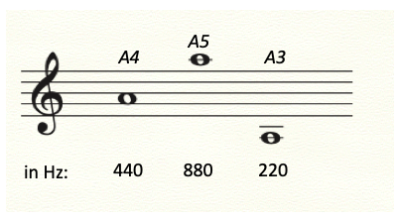

Figure 1.3 A440 and its octaves represented by notation and waves.

Three octaves of the note A on a music stave: A4 (440 Hz), A5 (880 Hz) and A 3 (220 Hz) and a 20 ms file showing the 2-fold change in frequency or each.

We have outlined numerous other parameters for music, so can you think of additional parameters measurements that could be used to describe or create music?

How much does sound weigh?

A strange question, and the answer is … tiny.

Weight is defined as mass (in kg) times the acceleration of gravity (in m/s²), also known as “force”. While your body’s mass is the same on every planet (in units of kg/human), you weight is different depending on gravity: if you “weigh 100 kg”, this is because you register 100 kg on a bathroom scale calibrated for Earth’s gravitational force.

While we generally think of grams as a measure of weight, to physicists, weight is the force of gravity on some object and is measured in newtons (N) where 1 N = 1 kg*m/s².

For the acceleration of gravity of the Earth, 1 kg yields 10 N. On Jupiter’s stronger gravity, 1 kg yields 25 N, so you weigh 250% more, and on the moon, where 1 kg yields 1.6 N, 84% less.

On the Earth at sea level, a 1 cm² column of air from the ground to the top of the atmosphere has a mass of 1 kg. A column of air over a square meter (100 cm * 100 cm = = 10,000 cm² = 1 m²), has a mass of 10,000 kg. In earth’s gravity, 10,000 kg weighs 100,000 N.

We can covert newtons of weight to units of sound pressure, which you will remember from the calculation of loudness in dB, is a weight per area and measured in units of Pascals (Pa)

1 N/m² = 1 Pa

The air over a square meter at sea level then has an air pressure of 100,000 Pa. This standard air pressure at sea level is also called 1 “bar” of air pressure.

Remember from our analysis of loudness that a dangerously loud sound of 140 dB corresponds to a peak of 200 Pa.

At the peak of a 140 dB sound wave, the weight of air at sea level increases only from 100,000 to 100,200 N/m²: even an extremely loud sound weighs at its peak is at most 0.2% of the weight of air.

So finally, on the surface of earth, an extremely loud sound changes the mass of air from a trough of 9,980 to a peak of 10,020 kilograms/ m². This is indeed tiny, but as we will read later, the ear responds to the change in pressure, and this tiny change of mass can produce a deafening change of pressure at the eardrum.

With the Russian satirical painters, Vitaly Komar and Alex Melamid, we went to an extreme of using parameters to create music by polling the public for their likes and dislikes. Their answers to a survey created the The People’s Choice Music, the Most Wanted and Unwanted Songs.

The Most Wanted Song uses a band three to ten instruments consisting of guitar, piano, saxophone, bass, drums, violin, cello, synthesizer, with low male and female vocals singing in rock / r&b style. The favorite lyrics narrate a love story, and the favorite listening circumstance is at home. It is 5 minutes long, moderate pitch range, moderate tempo, and moderate to loud volume.

The Most Unwanted Song is over 25 minutes long, veers between loud and quiet sections, between fast and slow tempos, and features timbres of extremely high and low pitch, with each extreme presented in abrupt transition. The Most Unwanted Orchestra features the accordion and bagpipe (which tie at 13% as the Most Unwanted Instrument), banjo, flute, tuba, harp, organ, synthesizer (the only instrument that appearing in both the Most Wanted and Most Unwanted ensembles). An operatic soprano raps and sings atonal music, advertising jingles, political slogans, and "elevator" music, and a children's choir sings jingles and holiday songs.

The Most Unwanted subjects for lyrics are cowboys and holidays, and the Most Unwanted ways to listen are involuntary exposure to commercials and elevator music. By statistical analysis, fewer than 200 individuals of the world's total population enjoy this piece.

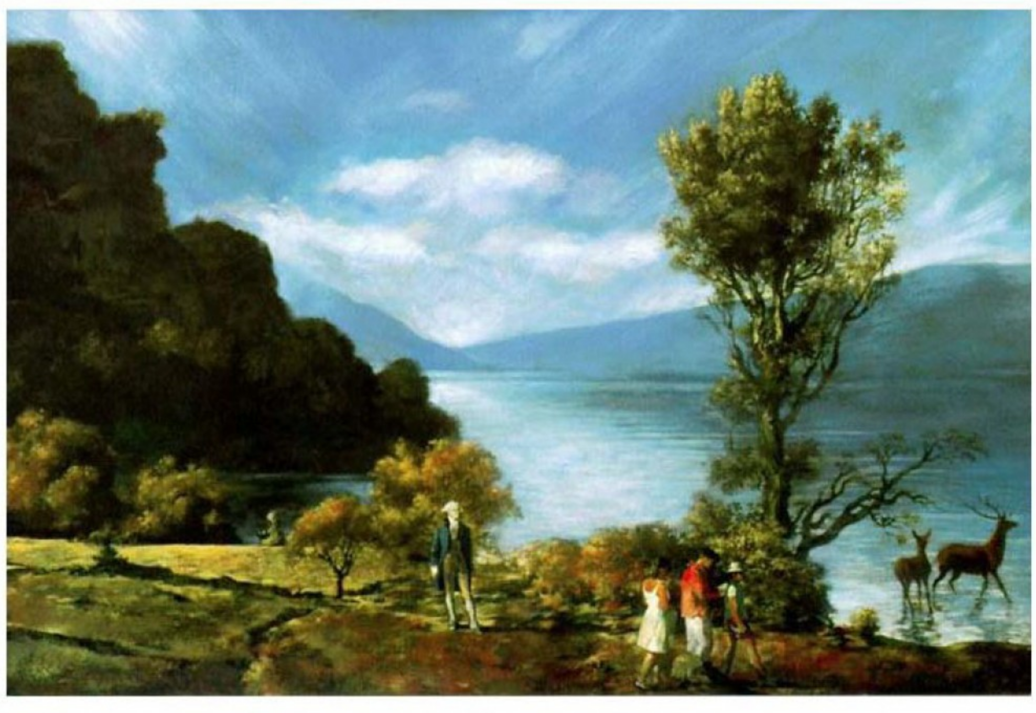

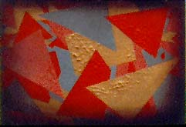

Figure 1.4 The Most and Least Wanted Paintings

The most and least wanted paintings for the United States. Reproduced with permission by Vitaly Komar.

Why do sirens rise and fall in pitch?

The Doppler effect (after Christian Doppler, 1803 -1853) explains why the sound of a siren rises in pitch as a police car approaches and then descends as it drives away.

Say the siren pulses air at the A4 above middle C, 440 Hz. This corresponds to a time t between the air pulses from the siren of

t = 1/f = 1/ 440 (wave/s) = 0.0023 s

As we learned above, we can also calculate the wavelength between each siren pulse using the speed of sound (343 m/s)

c / f = λ

(343 m/s) / (440 wave/s) = 0.78 m/wave

If the police car is stationary, the situation is simple, and this is what a listener will hear. Also, if the car is moving, this is what the policeman inside the car will hear.

But if a police car is driving straight towards you with its siren blaring, the frequency you hear is higher because by the time that the siren emits its next air pulse, it travels a shorter distance to reach you.

If the police car is driving towards you at 100 km/h (28 m/s), by the time of the next air pulse, the siren is now closer to you by a distance of

0.0023 s * 100 (m/s) = 0.23 m

and as long as the car drives straight towards you, each pulse is sent from a source 230 mm closer to you. That is, the speed of sound is the same, but the sound arrives from a closer siren.

By how much is the frequency increased for the listener?

To calculate this, add the speed (velocity) v of the car (28 m/s in this example) to the speed of sound

343 m/s + 28 m/s = 371 m/s

Since we now know the speed that the air pulse travels relative to you and that the wavelength of a 440 Hz sound is 780 mm, we can calculate that the air pulses that arrive to you is a frequency of

(c + v) / λ = f

(371 m/s) / (0.78 m/wave) = 476 wave/s = 476 Hz

which is a higher note (see Appendix 1) between Bb4 and B4 above the A4.

As the car drives away from you, the air pulses the wavelength between the pulses arrive at a lower frequency as they are arriving at the speed of sound MINUS the speed of the car, or

c - v = 343 – 28 = 315 m/s

f = (315 m/s) / (0.78 m/wave) = 403 Hz, between the G and G# below A

To calculate this more efficiently, if f_{s} is the pitch when a police car and listener are stationary (or to the police sitting inside the moving car), and f_{m} the pitch when the source or listener move, we can divide them: if the siren is driving away at a velocity v

f_{s} / f_{m} = (c / λ) / (c - v / λ)

the wavelength produced at the siren is the same, and cancels

f_{s} / f_{m} = c / (c - v)

and f_{m} = (c / c - v)) * f_{s}

Say you are bicycling at 10 m/s towards a siren producing a high A5 (880 Hz) frequency: add the speed of sound plus the velocity of the bicycle (for 353 m/s) and you can calculate the change in pitch as

(353 m/s) / (343 m/s) * 880 Hz = 906 Hz

As like occurred to you, one is not typically directly in front of a speeding car, but (ideally) off to a side. If you are sitting in the bleachers in front of a racetrack at 6 o’clock, and the cars are driving counterclockwise, they travel toward you at their maximum velocity when they are at 9 o’clock and away the fastest at 3 o’clock, and so you hear the most rapid changes in frequencies at these positions. The driver however hears the same frequency throughout.

You might imagine composing a piece with moving notes made by moving sirens, or the listener, at a range of vectors, moving towards or away from each other: the pitches will be different for people at different points.

Astronomers established a creative use for the Doppler effect. Light travels at a constant velocity, but the wavelength emitted from a star also stretches or compresses. The light wavelengths we perceive range from blue at 390 nanometers to red at 700 nanometers (note that we hear over a range of 10 octaves of frequency but our range of color perception is less than one octave). Edwin Hubble (1889-1953), noting that the most distant galaxies appeared red, suggested that the “red shift” was due to the galaxies moving away from us, indicating an expanding universe.

Figure 1.5 The Doppler effect.

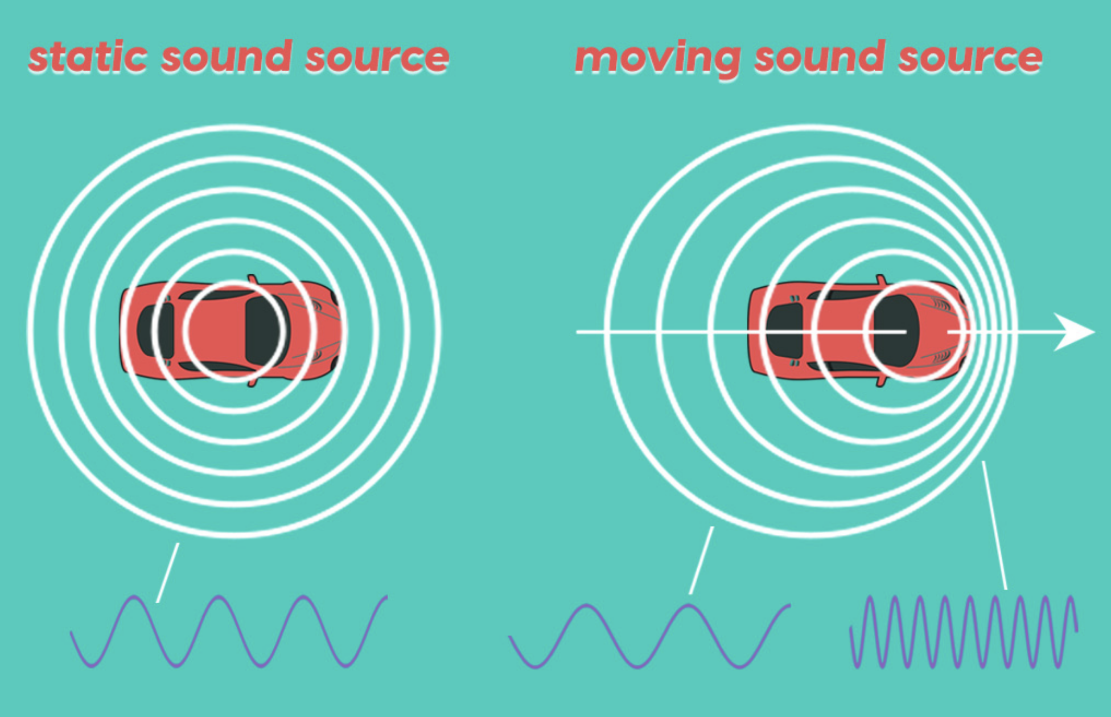
Note to Lisa: rather than a still car, let’s make the one on the left to someone inside the car

The air pulses from a siren occur at a repeating regular frequency and to a policeman inside a moving car, the siren at a stable rotation plays a constant frequency. But to someone standing outside the car, while emitted puffs of air always travel at the speed of sound, the pitch changes relative to where she stands. Someone in front of the path of a speeding firetruck receives each subsequent siren puff emitted from a shorter distance and so they arrive at a higher frequency and pitch. For a listener behind a siren moving away from them, each successive air puff has a longer distance to travel and the frequency decreases.
A special case of the Doppler effect produces the sonic boom heard when airplanes surpasses the speed of sound (1235 km/hour at sea level). Here, the velocity of the plane exceeds the speed of sound c and the sound waves emitted by its engines are very compressed, and when the plane is faster than the speed of sound, the wavelengths approach zero. From the formula above

f_{m} = (c_{m} / (c_{s} - v)) * f_{s}

but because the plane velocity is the speed of sound, the denominator is around zero. You can’t divide by zero! Small changes around zero result in the value of the frequency from the plane becomes very unstable and produces an enormous range of noisy frequencies that sounds like the wide frequency range of a thunder clap.

Listening

Very high and very low pitches are sometimes used in music with an intent to be disturbing.

For a high frequency note used in a classical composition, Gustav Mahler has piccolos play a C8 = 4186 Hz in his Second Symphony in the fifth movement (marker 18). It’s part of a big orchestral section with lower notes played at the same time, and not as disturbing as if the piccolo were played as a solo.

For examples of low frequencies used in concert music, listen to organs. In Camille Saint-Saen’s Third Symphony, known as the Organ Symphony, the end of the finale uses the lowest note on the organ, written as the C below the bass clef, which was classically called “low C” (C2). On a standard piano this would be 65 Hz, but organists on this piece use their stops to play their longest pipes, two octaves below

65 Hz/ 2 / 2 = 16 Hz, a fundamental frequency f₁ (C0) lower than we can perceive.

How long is the air wave of this very low C?

(343 meters/s)/16 Hz = 21.5 meters!

For an open organ pipe (you’ll learn about open and closed pipes in Chapter 3) the wavelength is twice the length of the pipe. The wavelength of middle C (C4) is about 4 feet (work it out) so the pipe is about 2 feet long (organ stops are still expressed in feet rather than meters). For the very low notes like 16 Hz, a cathedral needs room for a 10.75 meter (about 35 foot) open stop.

There are two pipe organs in the world with 64 foot tall stops, the contra trombone reed stop of the Sydney Town Hall Grand Organ and the diaphone-dulzian stop for the Boardwalk Hall Auditorium organ in Atlantic City New Jersey. The lowest C (C-1) is 8 Hz! To me, they sound like undersea monsters. Organist Stephen Ball has a nice demonstration of the lowest C played on the Atlantic City organ, which also happens to have the loudest stop in the world.

The Monterey Bay Aquarium Research Institute has a very low frequency recording of an underwater earthquake that requires a subwoofer or headphones to reproduce.

We’ll discuss low frequencies produced by elephants and whales in the last chapter. For those of us young enough to still hear it, 20,000 Hz is a high Eb10. Younger adults can usually hear 15,000 Hz, the Bb9 below the high Eb10, a high frequency currently on the border for your author. While the difference between 15 kHz and 20 kHz is only 4 whole notes on the piano, some sounds that define the consonant sounds in spoken language are exactly in that range and loss of response in that regions is in part responsible for older listeners confusing words.

If music is really made from waves, shouldn’t one be able to create music by simply drawing waves and then playing them back? This was done by animators in Russia in the 1920s through the 1940s, listen and watch Les Vatours by Igor Boldirev and Evgeny Sholpo and anything by Nikolai Voinov using paper sound.

Music constructed from extreme parameters of quiet, slow, and long duration was a specialty of Morton Feldman: listen a bit to the Second String Quartet, which is over 5 hours long.

Music constructed from extreme parameters of loud, fast, and short duration was a specialty of the hardcore band Napalm Death: listen to the deathless 3 second classic You Suffer, but first you might decrease the volume setting on your playback system.

If you are in a safe environment with no means to hurt yourself or others, venture a few minutes of parameters designed to frustrate you in my The Most Unwanted Song with the Russian conceptual artists Komar and Melamid and lyricist Nina Mankin.

2. Math of pitch, scales, and harmony

- How are musical scales made?
- Is it really impossible to play in tune?
Our assignment for this chapter is to relate 35,000 years of history in music in 10 pages…

We know that our species perceives fundamental frequencies from 20 to about 20,000 Hz. A piccolo’s highest notes are under 5000 Hz and even professional flutists find them pretty irritating. A range from 20 to 5000 Hz provides our species with a tremendous set of fundamental frequencies to create music.

A composition that takes advantage of a large number of possible frequencies is Phill Niblock’s 5 More String Quartets, which uses 500 fundamental frequencies in a single piece.

But this is extremely rare. Excluding sliding into or out from a particular frequency, about 99.9999 % of music our species listens to uses very few fundamental frequencies, usually between 5 to 12 and their powers of 2 multiples (this will make sense shortly).

The world scale means “steps” in Italian. The ordering of a small set of frequencies produces a musical scale. In most cultures, the choice of a scale has a mystical significance: Ling Lun was said to have developed the Chinese five note ‘pentatonic’ scale by cutting bamboo to lengths that imitated specific bird song. Scales are nevertheless based in math, even in cases where notes are derived by what sound “right”.

The derivation of scales is classically explained by dividing a string, like a string on a guitar, and the most classic approach is to use a single string instrument known as a monochord that we will discuss shortly. The positions that produce specific notes on a string also apply to tube shaped wind instruments that vibrate an interior column of air like flutes and organ pipes. The positions of the holes on ancient flutes made from bird bones reveal the pitches of scales played 35,000 years ago.

Bird bones are hollow, and so good for making flutes, and they can survive a long time. At this writing, the oldest known flutes are from the Upper Paleolithic period and at least 35,000 years old. These were found in three caves in the Jura mountains of Swabia in Germany, and are old enough that the inhabitants also had bones from mammoth and wooly rhinoceros. Indeed, fragments of at least one flute made from mammoth ivory have also been found in these caves.

The most complete of these flutes found to date was discovered by Nicholas Conrad and colleagues in the Hohle Fels cave. It is made from a griffon vulture bone and has at least four finger holes, appears to have had a fifth and could fit six. The flute was in pieces, but a replica built from a vulture bone by Wulf Hein plays a four note scale: C, D, F, B, C with a higher octave D and F.

The oldest intact flutes are 9,000 years old and made from red crowned crane bones. They were discovered by Juzhong Zhang and colleagues in Henan Province in China. The best preserved has 7 main holes and plays a 6 note scale: A, B, C, D, E, F#, A. This corresponds to a pentatonic Pythagorean tuning with one extra note, starting on a fundamental of D.

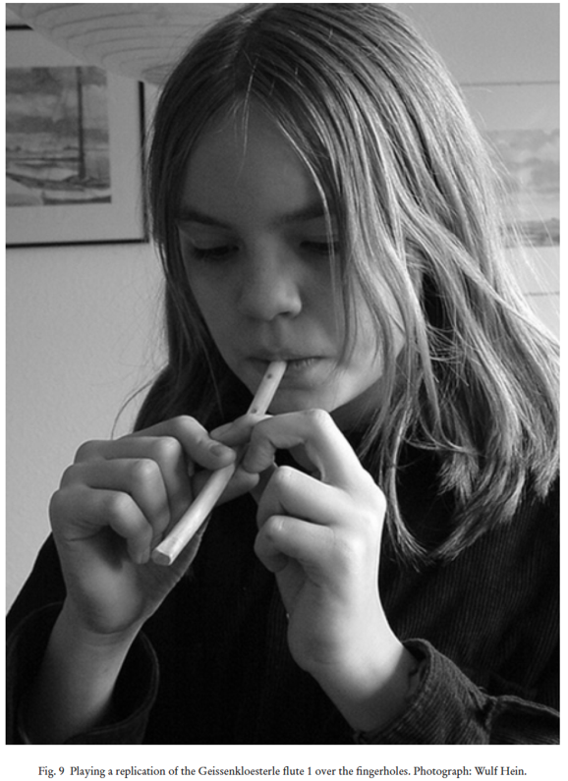 | Figure 2.1 Replica of one of the the oldest flutes discovered,  at least 35,000 years old, in the Geissenkloesterle cave in southern Germany, and constructed of a whooper swan wing bone. (It was apparently imported as other swan bones have not been found in the cave.) This reconstruction has three holes that play a five note pentatonic scale. Replica built and photograph by Wulf Hein, and played by his daughter, used with permission.

In keeping with the mystical connotations of tuning, the process of defining scales is sometimes explained in mumbo jumbo that, in the words of Nietzsche, “muddy the water to make it appear deep”. Here I promise that you need to use only multiplication. Everything can be derived with a spreadsheet, and a string instrument like a guitar will be very helpful. Nevertheless, as you more thoroughly understand scales and tuning, you might also find the revelations mystical and awe-inspiring.

In western literature, the history of scales and tuning usually begins with the legendary mystic mathematician Pythagoras (around 570-495 BC, born in the Greek island of Samos); and why not?

Pythagoras was an eccentric pacifist vegetarian searching for universal truth – although the story of Hippasus provides an ancient warning about following charismatic professors –– and like some other inspirational figures, he left no writing that might check our imagination, but rather a tradition of interpreters free to reimagine his theories.

- Pythagoreans taught that all numbers, including musical intervals, are rational, meaning that they can be expressed as the fractions composed of whole numbers.
They also taught the Pythagorean theorem, in which the long side of a triangle (the “hypotenuse”), is calculated by adding the squares of the other two sides and taking the square root of the sum:

for example, 3² + 4² = 9 + 16 = 25 = 5²
and so the long side is the square root of 25 = 5.

If the shorter sides of a triangle are both 1 unit, as 1² + 1² = 2, the long side is the square root of 2.
A Pythagorean, Hippasus, is said to have demonstrated to outsiders that the square root of 2 could not be expressed as a simple number ratio, i.e., that a number can be irrational. It is also said that for this, other Pythagoreans drowned him at sea.
The Pythagoreans thought that beans were sacred and would not eat or even step on them, It was reported that Pythagoras died near his school in Croton in Calabria by an invading army from Sybaris because he refused to escape across a field of beans.

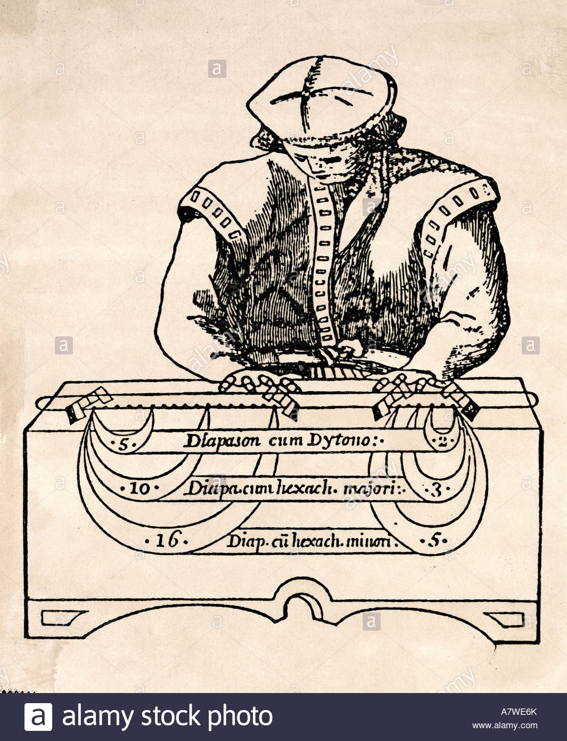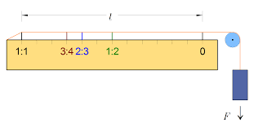

Figure 2.2. a monochord
We should show the divisions as the one on the right but with “1/2” instead of 1:2, and then use brackets to label the length of the string that makes the full string ½ for DO, octave DO (1/2), fifth SOL (2/3), fourth FA (3/4), third MI (4/5), minor third (5/6), second

A question I ask students: if you don’t have a ruler, how can you find the exact midpoint of the string?

Using a guitar or monochord, stop the string from vibrating somewhere in the middle with your finger on a guitar, or with a moveable bridge on a monochord – and pluck the string on either side. If the note is the same when on both sides, ecco, that is ½ the length. On a guitar, this is at the 12th fret.

This simple observation has given people the shivers for three millennia:
1/2 the length of the string plays a note that is twice the fundamental frequency of the open string: 2/1*f₁.

In other words, turn the fraction ½ upside down, and that gives you it’s reciprocal, 2/1, an octave. This means that 1/2 the string length plays twice the frequency, and also means that to play a lower octave at ½ the frequency, you require a string exactly twice as long.

The many tuning systems are based on this eureka moment.

To find where a given note lies on a string:

in Chapter 1, we found that for a wave or vibrating string

λ = c / f

if you stop a string between the ends with your finger or a bridge, you produce two lengths of string, A and B

λ_{Α} = c/f_{A}
λ_{Β} = c /f_{B}

if we divide one by the other,

λ_{Α}/λ_{Β} = ( c/f_{A}) / (c /f_{B}) = ( c*f_{B}) / (c* f_{A})

c cancels out

λ_{Α}/λ_{Β } = f_{B} / f_{A}

which we rearranged as

λ_{Α}/λ_{Β} ∗ f_{A} =   f_{B}

For example, if a guitar string is tuned to A 440 Hz and you stop the string with a bridge or finger at 1/3 it’s length (on a guitar this corresponds to the 7th fret), the frequency of the shorter side is

3/1*440 Hz = 1320 Hz

which is the note E an octave and a half higher (see Appendix 1)

and the longer side would vibrate at

3/2*440 Hz = 660 Hz

the E an octave lower than the shorter side.

The Pythagoreans, as well as ancient Chinese and likely Egyptian musical theorists before them, were enchanted by these relationships, as they realized that the notes of the scale can be calculated from rational numbers. This reinforced the idea that there must be rational and universal relationship of numbers in physics and art: the universe makes sense!

As you read already in the Hippasus story, this euphoric state didn’t last even in the ancient world. The vast majority of today’s music uses irrational numbers, and the tension between the pure rational and workable irrational continues to haunt us.

Octaves and tetrachords

The relationship between two notes related by doubling (2/1) or halving (1/2) a frequency is called the octave: of course, octo means 8, not two… but it’s because the Greek scales had 8 notes.

So how many notes are in scales? In western music traditions, we still mostly think of scales as 8 notes:

DO, the “fundamental”
RE, the “second””
MI, the “third”
FA, the “fourth”
SOL, the “fifth”
LA, the “sixth”
TI (or SI), the “seventh”
and in the words of Oscar Hammerstein, “and that brings us back to DO DO DO DO”, the higher octave note that ends one octave and begins the next.

This scale is called in contemporary parlance “diatonic”: it is not what the Greeks meant by that term, which was a specific tuning of an eight note scale, but so be it. Because, however, there are actually seven different scale degrees, this is sometimes call a heptatonic scale, causing no end of confusion. To avoid even more confusion, we join the herd by counting DO twice, and call this an 8 note scale. The Greeks considered DO as a synaphe, which belongs to both octaves.

In India around 700 B.C., the Chandogya Upanishad divided the octave into 22 parts, and this approach is still taught, but our widespread friends, the 8 note scales, are the most often used for ragas. The scales for raga are very complex and may change depending if a melodic phrase is moving to higher or lower directions. The classical music teaching tradition the 8 note scales using the syllables:

SA RE GA MA PA DA NI SA

And while most Chinese melodies use five notes, an 8 note scale is typically taught.

The note names come from a hymn, Ut Queant Laxis, by Guido of Arrezzo (991-1033), credited as inventing the musical staff for notation, which honored John the Baptist using the first six pitches of the scale at the start of each line,

It goes:
UT queant laxis
REsonare fibris
MIra gestorum
FAmuli tuorum
SOLve polluti
LAbii reatum
Sancte Iohannes

And be loosened, resonantly sing, [or your] miraculous works, [by] your servants, loosen [our] unclean, guilty lips, St. John

The modest theoretician Giovanni Doni (1595-1647) changed UT to DO as it is easier to sing, it’s the first syllable of Dominus (God) and also his own name. As the last phrase doesn’t begin with the seventh degree, someone added the name

Sancte Iohannes, which (Sarah Ann Glover (1785-1767) substituted TI, to have a different first letter than SOL.

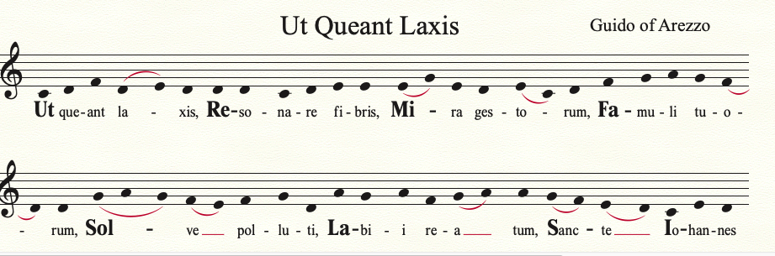

Figure 2.3 UT a deer.

A hymn to John the Baptist by Guido of Arezzo (~991 – 1033) from which were derived the names of RE, ME, FA, SOL, and LA.

Alternatively, DO was derived from the “DOH” as used by the Springfield hymn poet, Homer son of Simp.

There alternate answers to eight notes are in an octave scale. Much of the world’s most popular music uses five notes, known as pentatonic scales (yes, they should be called hexaphonic if you count DO twice), including the majority of Thai, Chinese, and Ethiopian music, and a lot of blues. Composed western music from Bach onward often uses 12 notes per octave (not counting the synaphe DO twice), and the composer and instrument builder Harry Partch used 31 notes in an octave. Each of these choices of scale degrees provide the basis for the style of music.

Just intonation

The word music is derived from the Greek goddesses, the Muses, and lyrics from their instrument, the lyre, which provided the backup for the lyrics of Homer and Sappho. The lyre was used to accompany singer-songwriters as guitars, keyboards, and laptops are used presently.

The lyre of the lyric poets was a harp of 8 strings (cords or chords) per octave (as one counts DO twice). The Greek lyre is not very different than the harp of David in the bible, which in the Psalms is said to have 10 strings, or the Ethiopian begena which also has 10 strings and is said to be David’s harp as brought to Africa by King Menelik I, said to be the son of King Solomon and the Queen of Sheba circa 950 BC. It is also very similar to the begena’s close and popular relative, the 5 or 6 string Ethiopian kraar, which is used to accompany sung long form poetry. (The lyre is very different than the contemporary Greek instrument, the lyra, which is a violin and still widely used to accompany lyric poetry in Crete.)

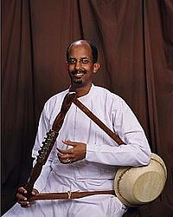 | 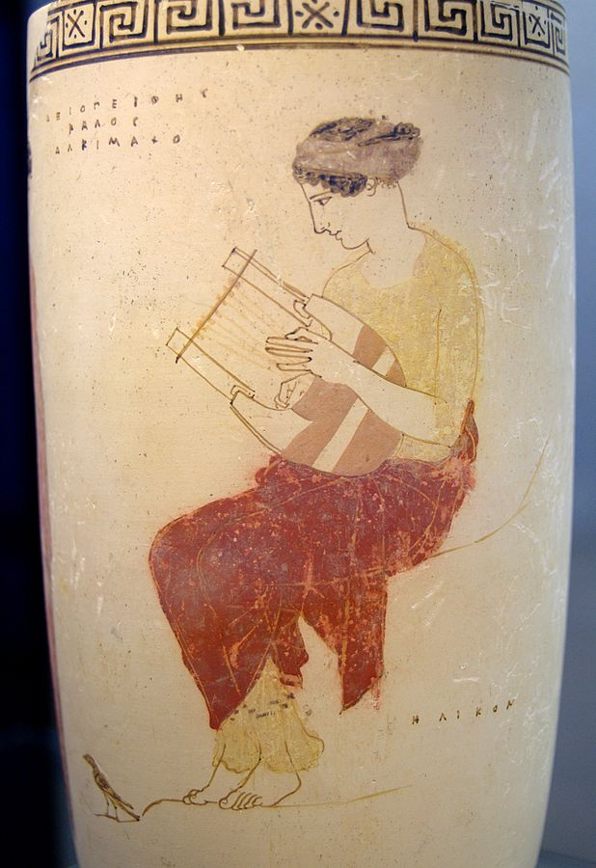

Figure 2.4 Images of a begena and lyre

The contemporary Ethiopian musician Alemu Aga playing a begana and a muse playing a six string lyre on Mount Helicon with a magpie at her feet, attributed to Achilles Painter about 334 BC from Staatliche Museum Antikensammlungen, Municih, Creative Commons.

On the lyre, the frequencies between f₁ and f₂ were divided into 4 lower and 4 higher strings, known as the two tetrachords: the first as DO, RE, MI, FA and the second SOL, LA, TI, and a high DO. Hence the use of the term octave, from two tetrachords, even though there are only 7 different note names.

The relationship between the low and high DO you already know: the string is divided in half (the 12th fret on the guitar), and the frequency of the half of the string is 2-fold higher, the octave.

As good Pythagoreans who find simple rational numbers to be spiritually satisfying, we would want to analyze the next whole number fraction, dividing the string by 3. If you press on the string at 1/3 of its length (the 7th fret on the guitar), you leave 2/3 of the length free to vibrate. The resulting frequency of the longer side is the reciprocal, (3/2)*f₁. So, to divide a string by a third by sound alone, use the open string as DO, and find where to stop the string to hear the note SOL, the “fifth” degree. The frequency 3/2* f₁ is used in virtually all tuning systems. (A rare exception is the tuning or some gamelan orchestras.)

Let’s now follow this pattern by dividing the string by 4. Press the string at ¼ of its length (the 5th fret on the guitar) and ¾ of the string vibrates at the reciprocal frequency of (4/3) *f₁. This is the fourth degree of the scale, or FA.

Now take a breath and see what we have just done. We derived the octave DO from dividing by 2: the fifth degree SOL from dividing by 3: and the fourth degree FA from dividing by 4. These are classically known as the perfect intervals, and are identical for all of the ancient tuning systems.

This still leaves the 2nd, 3rd, 6th, and 7th degrees that result from smaller fractions reciprocals of higher numbers and are known as the imperfect intervals. The flavors of 8 note scales, particularly major and minor scales, come from these.

The next division is the first imperfect interval. Divide the string by 5 (close to but not exactly at the 4th fret of the guitar), leaving 4/5 of the string to vibrate, and we have a frequency of (5/4)*f₁, known as the third degree, the note MI. (5/4)*f₁ is specifically a major third. This frequency is pretty close to that you would hear on the typical piano or guitar, but a little bit flat.

Let’s next divide by 6, so 5/6 of the string vibrates (close but not exactly to the 3rd fret of a guitar), with a frequency 6/5*f₁, which is a smaller third degree or MI, as the minor third is 6/5 = 1.2, whereas the major third 5/4 = 1.25.

Ecco, you have discovered basis for the minor scale! Even millennia later, the classification of a major vs. minor scale is still defined by the major (5/4) or minor (6/5) third. In contrast to perfect intervals, the third degrees are liquid enough that a great deal of the flavor of the blues come from stretching where the third degree frequency is placed.

Now we jump to a couple of important string divisions. The division by 9 yields 9/8 = 1.125, and dividing by 10 yields 10/9 = 1.111. These are two different ways of obtaining the second degree, RE. (These are both close, but not too close, to the second fret on a guitar.)

So for the first tetrachord of a lyre, we have by dividing the string length by small whole numbers, arrived at string lengths and frequencies for each note. Here is the tetrachord of “Didymus the musician” who lived around 0 AD, which uses a major third.

note name DO RE MI FA
string length 1 8/9 4/5 ¾
frequency 1 9/8 5/4 4/3
frequency in decimals 1 1.125 1.25 1.333

a simple way to calculate the lyre’s second tetrachord, since we start at SOL, (3/2)*f₁, is to repeat the process by multiplying the first tetrachord ratios by 3/2.

note name SOL LA SI DO
string length 1 16/27 8/15 1/2
calculation 1*(3/2) (9/8)*(3/2) (5/4)*(3/2) (4/3)*(3/2)
frequency in fraction 3/2 27/16 15/8 2
frequency in decimals 1.5 1.6875 1.875 2

Voila! There are many, many other possible variations for 8 note scales.

For example, a scale advocated by Claudius Ptolemy around 100 AD differs by using 10/9 for the second degree.

The approach of using smaller whole number divisions of the string to derive a scale is known as just intonation.

I hope that the thrill that this most fundamental building block of music can be calculated by rational numbers produces the satisfying glimpse into the cosmos for you that it did for your intellectual and spiritual ancestors. Just intonation was the inspiration for attempts to discover “the music of the spheres”, in which rationally derived musical note degrees were used to understand the structure of the universe.

There is a long effort to use the musical ratios to describe the cosmos. In Shakespeare’s Pericles, only the title character can hear the music of spheres when his long-thought dead daughter returns.

The most famous development of the concept was by Johannes Kepler, who discovered that the planets rotate the sun in ellipses, in his 1619 book, Harmonices Munde, known as the Music of the Spheres. He wrote

We are to think of such circles (the orbits of the planes) as like monochord strings bent round, vibrating, and study the extents to which the parts are consonant or dissonant with the whole.
(Book III, chapter 1).

Since he discovered that planets move elliptically rather than in perfect circles, Kepler could determine the ratio between the maximum and minimum speeds during their orbit. For the earth, he determined this to be 16/15, corresponding to a half step, which in the diatonic scale is also the interval between MI and FA. He wrote

The Earth sings Mi, Fa, Mi: you may infer even from the syllables that in this our domicle MIsery and FAmine hold sway.

Venus, in contrast, produces a single note, as its orbit is nearly a circle. All of the planets might occasionally align in perfect harmony, perhaps at the time of creation.

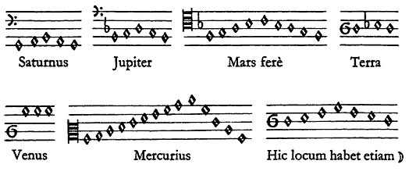

Figure 2.5 Kepler’s music of the planets.

Each planet has intervals defined by its elliptical orbit (in order, Saturn, Jupiter, Mares, Earth, Venus, Mercury and the last indicates the moon). Venus, which is nearly circular, produces a drone, the Earth sings intervals of famine and misery, and Mercury rapidly climbs and descends in broad waves.

In 2003, Andrew Fabian and colleagues, cosmologists studying black holes in the Perseus galaxy cluster, discovered an enormous gas wave with a wavelength of 36,000 light years and a frequency of 10 million years, which they calculate is a super low B flat, 57 octaves below middle C.

Now that you understand the derivation of ancient just intonation 8 note scale, the assignment to you dear reader, is to use their rules to come up with your own.

The “circle of fifths” and the 12 note scales

Despite the association of rational numbers with Pythagoras, the so-called “Pythagorean tunings” are derived differently, by successively dividing the string by 3 to produce a circle of fifth degrees. The idea here is that each new frequency can in turn form its own new series of frequencies. Yet within this design lies the eventual seed of its own destruction.

So how can you do produce a scale from one fraction? Just as for the second tetrachord, we could multiply the fifth degree frequency SOL, 3/2, by itself:

(3/2) * (3/2) = (3/2)² = 9/4.

As notes within an octave must have values between 1 and 2, we need to bring this back to the original octave by dividing by two:

9/4 * ½ = 9/8.

Do you remember that frequency? It is the just intonation major third, RE, of Didymus the Musician.

Let’s start at the frequency of RE and multiplying it by SOL:

9/8 * 3/2 = 27/16 = the just intonation sixth degree, LA.

Once more, LA times SOL:

27/16 * 3/2 = 81/32 = 2.531…

This number is larger than 2 and so would be a note higher than the octave, and so we lower it an octave by dividing the frequency in half:

81/32 * ½ = 81/64 = 1.266…

which is a tiny bit larger than 5/4 = 1.25, and so just a bit sharper than the just intonation third degree, MI.

Oh dear, we are now beginning to drift away from just intonation.

At this point, we have arrived at a five note Pythagorean pentatonic scale:

DO RE MI SOL LA

note name do re mi sol la
frequency as fraction 1 9/8 81/64 3/2 27/16
frequency in decimals 1 1.125 1.266 1.5 1.6875

This scale may be the most widely used in the world, and includes most popular songs from China, Thailand, Korea, Ethiopia, many Celtic folk tunes, many blues songs, and a lot of American pop music, for example, the verses of Stephen Foster’s Oh Susanna.

This Pythagorean tuning system can be continued ad infinitum, but something special happens at:

3/2 * 3/2 * 3/2… twelve times,

which is called “3/2 to the twelfth power” and written as (3/2)¹².

The number
(3/2)¹² = 129.7463379……,

a number a tiny bit higher than 128. Why is that important?

Recall that doubling the frequency produces a note that is one octave higher. Each higher octave is an increased frequency as a “power of two”. This means that multiplying a frequency by 4, which is 2*2 = 2², produces a note 2 octaves higher, and multiplying by 8 = 2³ a note 3 octaves higher, and so on. “Two to the seventh power” is

2*2*2*2*2*2*2 =2⁷ = 7 octaves higher = 128.

So 12 times around the cycle of fifths almost, but not exactly, “brings us back to DO”.

This process also yields 12 notes and is the reason why western music uses a 12 note scales: advancing the fifth degree 12 times almost completes the cycle back to DO.

This 12 note scale is called by contemporary musicians the “chromatic scale”, which is not the ancient Greek use of the term, but so be it.

The “Pythagorean comma”, irrational numbers, and cosmological crises where the natural order breaks down

The reputation of Pythagoras has suffered a common fate, to be celebrated or blamed depending on the contemporary mores change.

The composer Tony Conrad wrote an essay, Slapping Pythagoras, that blamed him for all of the awful styles of composition that followed since he broke the rules of Nature and intellectual integrity: “you travelled abroad, imperialistically raped the East of its ‘Exotic’ knowledge, and returned with a plan to straitjacket your own people.”

But thousands of years before Tony’s condemnation of this vegetarian universalist, others realized the fatal flaw that has haunted theorists ever since.

(3/2)¹² = 531441/ 4096 = 129.7463379……

It is not an irrational number, as it is still a fraction of large whole numbers. BUT the difference between the just intonation octave of 2/1, and this octave from the Pythagorean cycle of fifths octaves overshoots the seventh power of 2 and is audibly “out of tune”. This inherent imperfection is still called the Pythagorean comma.

Here’s an alternate way to arrive at the dreaded Pythagorean comma. Let’s take the second degree, RE, which can be the frequency 10/9*f₁, and climb up 6 intervals, which would be (9/8)⁶*f₁. Contemporary musicians call this the “whole tone” scale (C,D,E,F#,G#,B,C).

In a perfect world, that should yield 1 octave, or 2*f₁, but

(9/8)⁶ = 2.02729...….

which is still a rational number but is getting pretty ridiculous for an ideal cosmos based on small number divisions.

Either with cycles of seconds or fifths, the frequencies are close to but overshoot the powers of 2 of perfect octaves. And as each new frequency can initiate its own family of division frequencies, these veer off further and further away from the original fundamental. For any scale of 12 notes per octave, we are doomed to live with a sort of crisis, the buzz of out of tune notes.

What to do?

The vast majority of music in our era uses instruments with notes of defined frequency, including the guitar, keyboards, and electronics, use the twelve tone equal tempered tuning system.

This widespread system nevertheless frustrates musicians and listeners throughout the world. Every blues musician bends their guitar strings or use a slide to reach pitches not limited by the instrument’s frets. Electronic keyboards in the Mideast often used retuned notes, and a Morrocan jazz pianist, Amino Belyamani, retunes two notes per octave, the E and B, about a third of a semitone flat, on the piano prior to his concerts. Nearly every vocalist sings notes that don’t match the pitches of the 12 equal system.

One of the important early piano designers, Johann Jakob Konnicke even contrstucted a “pianoforte for the perfect harmony” in 1796 to solve the problem of playing in tune. Konnicke used 6 keyboard manuals, each with its own set of strings, to provide just intonation for each key. It is said that Haydn and Beethoven played the instrument, but with so many strings it must have been to difficult to construct and tune, much less perform, to have succeeded as a better piano.

There are approaches to retain at least some just intervals for instruments with defined pitches. The most famous is by Andreas Werckmeister (1645-1706), who cheated – more politely called “tempered” as in tempering metal – four 3/2 frequencies (C to G, G to D, D to A, and B to F#) each by lowering one quarter of the Pythagorean comma. This was called “well temperament”, and the tuning “Werckmeister 3” is thought to have been advocated by Johann Sebastian Bach in his collection The Well Tempered Clavier, with two pieces in every major and minor key to show how well temperament could make satisfying music even in keys with 3/2*f₁ (SOL) that were flat. It drives proponents of alternative approaches to tuning – nowadays called “microtonalists” – to no end of exasperation when music textbooks misstate Bach’s intentions by saying that this collection of masterpieces was Bach’s endorsement of 12 equal tuning, which it certainly was not.

Since the Pythagorean comma produces an interval a bit larger than a true octave, another way is so very slightly shave down every interval in a 12 note scale so that 12 equal steps produce a perfect octave. The idea is not different from leap year, where we correct that the year is a bit longer than 365 days by making each fourth year 366 days, resetting the position of the earth and the sun to where it was 4 years previously.

The 12 tone equal system in such wide use now has been a long-term surrender, recognizing that if rational number intonation systems provide a Pythagorean comma, let’s at least get every octave in tune. To do so, we cheat the other pitches by shaving them down equivalently. The compromise had profound consequences for musical style, as it makes every step of the scale equivalent, and simple to jump from one key to another. This provides a basis for incredible explorations of harmony and overtone relationships within the straitjacket.

To be fair, the establishment of equal tuning was initially a radical egalitarian proposition, as it used irrational numbers to calculate the notes in the scale. And yet equal tuning is also dogmatic and oppressive, and some styles of music cannot be made in equal temperament without disaster. As the political philosopher Eric Hoffer wrote in The Temper of Our Time, “What starts out here as a mass movement ends up as a racket, a cult, or a corporation.”

Equal temperament has made it easier to place frets on a guitar, as the space between each note uses the same ratio and has made key changes easy. But in Indian classical music, a droned f₁ and 3/2*f₁ are played throughout a piece by a sruti box (sruti means the divisions of the scale) or tambura, and so deviations in pitches from just intonation are heard clearly, and as with the blues, a great deal of the art concerns how to move pitches to and away from small number frequency ratios. The modern sitar requires frets that correspond to just intonation spacing, and some frets can be moved to different frequencies depending on the scale used for the piece.

The irrational calculations of equal temperament.

To understand the math that enables equal temperament, remember that each higher octave doubles the frequency of the previous. So selecting our f₁, DO, at the concert A 440 Hz, the next DO, is 440 Hz * 2 = 880 Hz, the next higher 440 Hz * 2 * 2 = 440 * 2² = 1760 Hz, and so on. A scale that only has one note per octave -- in other words, all octaves -- is easy, each new note is f*2.

Our simplest next division of the octave would be two equal notes per octave. The middle note needs to be a frequency that when multiplied by itself arrives to the octave.

Wuh oh. The trouble is that the only answer for x * x = 2 is the square root of 2, written as √2. Remember Hippasus’s fate? This was the first irrational number, close to 1.4142…

So the two note equal scale is

DO note between FA and SOL DO
calculation f₁ f₁*√2 f₁*2
frequency 440 Hz 622.25...Hz 880 Hz

With A4 440 as the fundamental, this halfway note falls precisely on a 12 equal D#4. This irrational interval is known as the “tritone” or the “devil’s interval”. A majority of baroque, classical, jazz and popular music is based on finding ways to use the irrational √2 interval to increase tension and then resolve the tension to a small number ratio. Indeed, every jazz musician knows the harmonic sequences they call “ii Vs” that resolve this very tension and provide the building blocks for the popular tunes of the great American songbook

This devil’s interval, central to an extraordinary range of musical styles, required the non-Pythagorean use of irrational numbers.

Then, to divide the octave into 3 equal intervals requires the number x for which x*x*x = 2, which is known as the “cubed root of 2”, which works out to 1.2599…

And jumping further ahead to 12 interval equals, the number x for which x*x*x*x*x*x*x*x*x*x*x*x = 2, known as the “twelfth root of 2”, is 1.0595…

OK, this is an ungainly irrational number, but the twelfth root of 2 makes some calculations easier and is the basis of most of the widely listened to music in our era. Want to set frets for a guitar up in twelve equal tuning? Simply make the string length for each pitch 1.0595… shorter than the one before. Same for where to place the holes on a wind instrument, or the length of reeds in a harmonica, or the length of a string in a piano, or an organ pipe.

Equal temperament simplifies calculation of the frequency of pitches. For 12 equal, each higher pitch increases the frequency by the “twelfth root of 2”, written as 2^{(1/12)}. Say A is 440 Hz, and you want to calculate the frequency of the Bb in the next octave higher. This is 12 steps to the next A, plus one more step to Bb, so 13 steps. You multiply 440 by 1.0595 thirteen times, that is raise 2^{(1/12)} to the “13th power”

(2^{(1/12)})¹³ *440 Hz = 932 Hz

How far off is12 equal intonation from Pythagorean or just intonation? For the 8 note scale

DO RE MI FA SOL LA Ti DO
just (Didymus) 1 1.125 1.25 1.333 1.5 1.688 1.875 2
Pythagorean 1 1.125 1.266 1.352 1.5 1.688 1.898 2
12 note equal 1 1.122 1.260 1.335 1.498 1.682 1.888 2

These don’t look too different, but can you hear if they are out of tune? Well, yes. To convert them to a scale starting at A 440, multiply each ratio by 440 Hz. The octave is obviously perfect. The next interval, SOL in 12 equal sounds quite close indeed, and is not noticeable. But MI audibly beats at 5 times per second. (We will have more on beats in the next chapter.)

Choices

In addition to the twelve note equal temperament and just intonation approaches, multiple other systems are in current use.

Arabic music in the middle ages used a 25 note unequal scale based on just intonation that is credited to the Persian philosopher al-Farabi in the 10th century. As mentioned, Indian classical music in theory still teaches a 22 note unequal scale based on the Chandogya Upanishad. In practice, both systems typically use 8 note scales, and the Indian raga system continues to use just intonation intervals.

Contemporary Arabic and middle eastern music has dealt with this in a different way.

The modern tuning system used in Arabic music, particularly the style known as maqam, system uses a 24 note equal tempered octave with quarter tones, that are in theory precisely halfway between the twelve note equal scale. The quarter tone scale is credited to the Lebanese theorist Mikha’il Mishaqah (1800-1888), who with his teacher adapted a the al-Farabi system. Nevertheless, maqam scales once again in practice use 8 notes, similar to DO RE MI or the Indian SA RE GA.

The most popular Turkish fretted instrument, the baglama or saz, uses a 17 note scale that is not equally tempered, with quarter tones under RE, MI, SOL, LA, and DO. Quartertones have some advantages including approximating some just intonation frequencies otherwise absent: for example, one of the quarter tones on the baglama plays the 11th harmonic.

Those who have studied the practical use of quarter tones in a range of Mideastern and North African traditions report that they are often not precisely in between 12 equal half steps, but are in perfect octaves with each other and heard clearly as in or out of tune. When players from outside the tradition play quarter tones a bit out of tune, Mideastern and Iranian musicians hear the music as definitively wrong and will stop the music until they are performed correctly.

Quarter tone synthesizers are popular in middle eastern music: a well known model, the Casio AT-5 Oriental keyboard, has 17 preset microtonal scales.

In addition to 12 and 24 tones per octave, other equal temperaments have their advocates. There was a movement towards a 17 note equal scale, which happens to approximate just intervals well.

Now that you know how to do it, an assignment is to invent scales of different equal temperament or just intonation.

Then to make it a harder challenge, consider that all of the tuning systems discussed so far, even those with equal temperament, require 2/1 octave and 3/2 fifths, but you can design your own scale that lacks perfect intervals. Given that perfect intervals have been the rule for at least 35,000 years, as for the ancient flutes, it’s unlikely that you will come up with a hit. Nevertheless, frequencies that are not related by octaves and fifths provide the mathematical basis of noise, as we will discuss, and provide a basis for noise music.

As promised, 35,000 years in a few pages. Is there an answer for how to make a scale that will please everyone? Not a chance. What will the future bring? Certainly, there are new ways to play precise frequencies, and with new technology we are not limited by the number of keys or holes on an instrument. But won’t that new technology simply bring us back to the state of a violin or a slide whistle or slide guitar or the voice, which can sound any frequency in their range? Why, yes it will.

Consider that the sound of a lush violin section or a church choir is in large part the sound of many voices playing slightly different frequencies, meaning that they are a little “out of tune”. Even the richness of sound and expressiveness of the piano relies on the three strings that are struck together being a tiny bit out of tune with each other.

A violinist’s or singer’s vibrato are often wider than some of the small interval differences that concern some who care about differences in the tuning of scales. My view is that it is desirable to understand the logic and consequences of tuning and scales, and it is also best to maintain a sense of humor about it in practice.

Harry Partch (1901-1974) read ancient Greek theory and the Sensations of Tone by Herman von Helmholtz (which also inspired this book) and decided that equal temperament was hopelessly corrupt. His Genesis of a Music (1947) describes how he arrived at a useful 43 note scale and then built dozens of instruments to perform it. He also was very strongly influenced by the Japanese music performed in kabuki theater, which is very effective at speech-like intonation and rhythm.

Perhaps the most amazing quality of Harry’s music is that it so resembles the intonation and phrasing of speech that it makes one hear speech as music for hours after, the way people on the street seem like zombies after a horror movie. He was notoriously obstinate, and had to be, living at times as a traveling hobo and forging a mostly unappreciated path, although he had fans including the composer and electronic music pioneer Otto Luening –part of the team that invented the synthesizer - who wrote the introduction to his book, and acolytes including Ben Johnston, another outstanding “microtonal” composer.

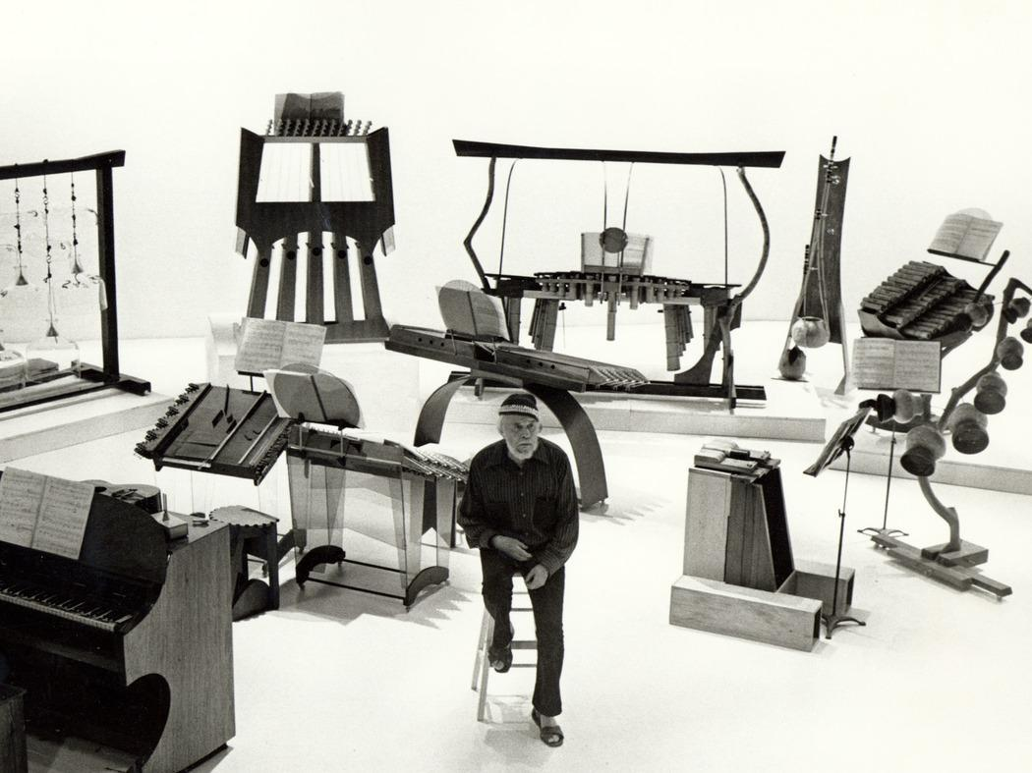

Figure 2.7 Harry Partch and his microtonal instrument ensemble.
Harry Partch with some of his specially designed musical instruments that together provide a 43 note per octave just intonation scale. The strings, blocks and bells can be tuned to specific frequencies using principles we discuss (for mallet like instruments, jump to our design of the elephant marimba in Chapter 11). For the chromelodeon organ at lower left, the reeds were cut to specific just intonation fractions marked in tape on the keys, and the entire typically 6 octave keyboard covers only 3 and a half octaves. Partch’s intonation system was based on the math of the Greek tuning systems we discuss as elaborated in his book Genesis of a Music. He often used these scales in a free manner evocative of jazz, rock, marches and music of the Japanese Kabuki theater, and the intonations of spoken English. permissions underway

Listening

Consider how being “in and out of tune” might provide mystery and beauty in sound.

It seems impossible to conceive that anyone does not know Do-Re-Mi a.k.a. Doe, a deer from Rodger and Hammerstein’s The Sound of Music (with co-composer Trude Rittmann) as sung by Julie Andrews, but if you are young and inexperienced, listen once. Really, once only or you will be sorry.

Listen to Phill Niblock’s Five More String Quartets to hear one composition that uses over 500 frequencies.

Ethiopian begana and kraar music, usually with 5 notes per octave and sung with lyric poetry, is probably similar to the ancient Greek styles and Hebrew styles associated with King David (see Psalms 33 and 137). It is used in compositions for the Ethiopian Orthodox church, known as Tewahedo. Great performers include Alemayehu Fanta and Tsehaytu Beraki on kraar and Alemu Aga on the larger and buzzier begana. You may be surprised at the vocal tone used in the singing and danceable rhythms in the Ethiopian styles, suggesting that other ancient music may have been sung with an emotion-laden gruff sound, as with contemporary flamenco and blues.

The ancient Egyptians used harps, as seen throughout their artwork, but while some of the ancient songs are still sung, the music and tunings of the harps are not clear. The Luo in Kenya (Barack Obama’s father was Luo) still play a similar harp, the nyatiti.

Epic poetry sung in the contemporary Greek style on lauto and lyra, particularly in Crete. The most popular epic in our era is the Erotokritos written in the 1600s by Vikentios Koranaros. A fine singer is Nikos Xilouris. One of the top players is Ross Daly, born in Ireland, but the acknowledged master of the Cretan tradition.

The music from Epirus in northwestern Greece still uses pentatonic scales and is thought to descend from the styles in vogue before the introduction of the diatonic scale. They adapted the clarinet in a distinctive virtuosic style and are renowned for polyphonic choirs with one soloist and others sometimes holding drones with the first syllable of the stanza. One fine player who carries on the tradition of the style of the island of Chiros in New York is Lefteris Bournias.

Pentatonic blues with a lot of in-between notes by Junior Kimbrough (try All Night Long), and pentatonic northern Lanna Thai hill country string music known as Salah San Seung after the names of the instruments: I recorded an album of their music near Lampang in 2005.

Johannes Kepler’s records are long out of print, but the composer/performers Willie Ruff and Laurie Spiegel have each prepared electronic renditions known as Harmony of the Spheres and Kepler’s Harmony of the Worlds, respectively.

Regarding the art of the third degree or MI and other blues intervals, and how the just intonation in part defines the music and can’t be right in equal temperament, listen to Muddy Waters singing Rolling Stone (the version recorded by Marshall Chess of Chess records). The guitar refrain between the vocal lines moves from below to up to the perfect 5th, Listen to the phrase “swimming in the deep blue sea” for an example of the blues 3rd, which is very close to the minor third 6/5, but with his bottleneck slide on the guitar, he moves up a bit towards the major 5/4. Consider that this song not only give the name to the band and the magazine, but that it uses one chord, and that it was one of the only hit records in America with one singer on one instrument. (I have no idea how the composer’s name links up with the Nietzsche quote in the chapter.)

Then John Lee Hooker’s Boogie Chillen (1948 version), similar yet different- also a hit recorded by one musician, the taps are Hooker’s feet-, with two chords. And Howlin’ Wolf’s Moanin’ at Midnight (the Sun Records 1951 version recorded by Sam Phillips), a hit record with one chord and an extravagant three instruments: Howlin’ Wolf on harmonica and voice, Willie Johnson on guitar (who sometimes sharpens the minor SI), and Willie Steele on drums: note “There’s SOMEbody knocking on my door” and the approach to the SOL in the humming introduction.

A creative extension on blues tunings is La Monte Young’s Forever Bad Blues Band, which used a just intonation keyboard and Jon Calter’s 31 note per octave guitar, with drummer Jonathan Kane providing the deep blues feel.

La Monte has a long running composition at the Dream House above his apartment at 275 Church Street in Manhattan, above a pizza restaurant. The current composition, which I believe can last indefinitely, is The Base 9:7:4 Symmetry in Prime Time When Centered above and below The Lowest Term Primes in The Range 288 to 224 with The Addition of 279 and 261 in Which The Half of The Symmetric Division Mapped above and Including 288 Consists of The Powers of 2 Multiplied by The Primes within The Ranges of 144 to 128, 72 to 64 and 36 to 32 Which Are Symmetrical to Those Primes in Lowest Terms in The Half of The Symmetric Division Mapped below and Including 224 within The Ranges 126 to 112, 63 to 56 and 31.5 to 28 with The Addition of 119.

Tony Conrad’s Slapping Pythagoras. The two tracks are Pythagoras, Refusing to Cross the Bean Field at His Back, Is Dispatched by the Democrats and The Heterophony of The Avenging Democrats, Outside, Cheers The Incineration Of The Pythagorean Elite, Whose Shrill Harmonic Agonies Merge And Shimmer Inside Their Torched Meeting House.

To hear genuine well temperament as intended by Bach’s Well Tempered Clavier, there is a beautiful recording of Oscar Nagler playing the Prelude and Fugue BWV 543 on the organ in Werckmeister III. Arthur Bocanneau produced a video with an electronic keyboard comparing three tunings including equal and Werckmeister III on the first Prelude in C.

Regarding further equal temperament divisions, any piece on the Turkish baglama, a virtuoso is Tolgahan Cogulu. For me, a classic use of quarter tones used in Arabic orchestral music is the work of Fairuz with the Rahbani Brothers from Lebanon, try her album of songs for Good Friday. For Persian quarter tones you might explore Madman of God by Sussan Deyhim, an American expatriate singer from Tehran.

Charles Ives wrote three pieces for two pianos tuned in quarter tones. This approach was developed further by Ivan Wyshnedgradsky who wrote for both quarter and 8th tones, the Arditti Quartet plays a nice version of opus 43.

Amino Belyamani has found a way to evoke Moroccan microtones to the jazz piano in his group SSAHHA by detuning E and B by about a third tone, that is 33 cents where 100 cents equals a half step.

There are an enormous number of modern compositions for alternate tuning systems, and a great source is the American Festival of Microtonal Music, run by Johnny Reinhard. Some personal favorites are Ben Johnston’s string quartets.

With computers and synthesizers, it is far more straightforward to produce precise pitches that change depending on the relationship, and the primary innovator for this is also a pioneer of the synthesizer, Wendy Carlos. Listen to Beauty in the Beast. On this recording she introduced alpha and beta scales that produces good triadic chords but do not use octaves.

You can listen to anything by Harry Partch, and there is a film of him, The Outsider, playing his instruments at home. For me, Harry comes the closest to expressing spoken English on musical instruments and makes you listen to everything in a different way.

Watch the astonishing University of Illinois 1961 version of Revelation in the Courthouse Park, which features the god Dionysus paired wtih the contemporary rock n’ roll god Dion (who must have been named in awareness of the singer Dion DiMucci from the Bronx’s Dion and the Belmonts). It genuinely combines elements of Greek Athenian and Japanese kabuki theater, John Phllip Sousa, Charles Ives, Busby Berkeley, big band jazz, circus bands, Rodger and Hammerstein’s Oklahoma, barbershop quartets and Chuck Berry era rock n’ roll.

Partch’s theater music is very strong influenced by impressions of ancient Greek theater and the Japanese Kabuki tradition, including the rhythms and the intonation of the vocals, and certainly the sounds of the instruments: one great recording is the 1954 Azuma Kabuki Musicians directed by Katsutoji Kineya and Rosen Tosha in a program of Nagauta Music. Kabuki was originally performed by women, but the tradition transformed to be performed by only men including singing the female characters.

